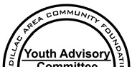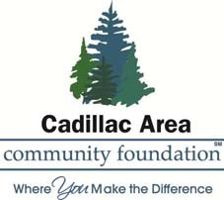

CADILLAC & KELLOGG FOR YOUTH COMMITTEE GRANT EVALUATION

Upon completion of the project or program for which you received a grant from the Cadillac & Kellogg for Youth Committee, an advisory committee to the Cadillac Area Community Foundation, please complete an evaluation answering the following questions. Please submit either one (1) hard copy of this evaluation to the Foundations offices at 201 N. Mitchell Street, Suite 101, Cadillac MI 49601 OR submit an evaluation electronically to cacf@cadillacfoundation.org prior to the one year anniversary date of the grant.

- NAME OF ORGANIZATION, ADDRESS, AND TELEPHONE NUMBER.
- CONTACT PERSON, POSITION AND TITLE FOR THIS APPLICATION.
- NAME OF PROGRAM FUNDED, AMOUNT OF FUNDS RECEIVED, AND DATE RECEIVED.

- BRIEFLY DESCRIBE AND EVALUATE THE GOALS/OBJECTIVES, AND RESULTS OF THE PROGRAM.

- DATES THE PROGRAM BEGAN AND ENDED.
- HOW MANY YOUNG PEOPLE, AND AT WHAT AGES, WERE INVOLVED IN THIS PROGRAM?

- DID YOU MAKE ANY CHANGES IN THE PROGRAM WHILE IT WAS BEING CONDUCTED?

IF SO, WHAT CHANGES & WHY? WERE THE CHANGES DUE TO UNANTICIPATED PROBLEMS OR CONCERNS? IF YOU RUN THE PROGRAM AGAIN, WILL YOU IMPROVE OR CHANGE IT?

- PLEASE ITEMIZE THE PROGRAM EXPENSES, BOTH CASH & IN-KIND
- WERE ANY CACF FUNDS NOT USED? IF YES, HOW MUCH?
(UNUSED GRANT FUNDS FOR THIS PROJECT/PROGRAM MUST BE RETURNED TO CACF.)

Revised 8/2014

