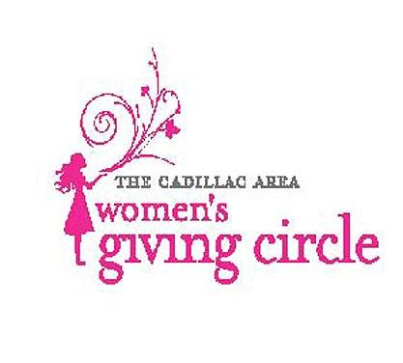
CADILLAC AREA WOMEN’S GIVING CIRCLE
a fund of the Cadillac Area Community Foundation
201 N. Mitchell St., Suite 101
Cadillac, Michigan 49601
Telephone: 231-775-9911
Fax: 231-775-8126
Email: cacf@cadillacfoundation.org

GRANT APPLICATION

The Cadillac Area Women’s Giving Circle supports projects that promote the economic self-sufficiency and well-being of women and girls. The Circle anticipates that it will award one to five grants between $1,000 and $7,500. You are invited to submit this cover sheet with a brief proposal for the Circle to review. After the initial review, you may be invited to meet with Circle members to discuss your project. Proposals must be postmarked by March 1

Name of Organization: ___________________________________________________

Address: ___________________________________________________

___________________________________________________

Phone Number: ___________________________________________________

Name of Project: ___________________________________________________

Amount Requested: _________________ Dates of Project: ________________

Contact Person: ___________________________________________________

Signature of Authorized Official: ___________________________________________

Please attach a brief proposal (two-page maximum) describing:
- Purpose: the innovative purpose of the program or project
- Need: the need that the program or project will help meet
- Objectives: the objectives of the project
- Benefits/Outcomes: what are the anticipated benefits/outcomes
- Evaluations: how you will measure the results of the projects
- Funding: a budget for the project (including any other funding) and plans for future sustainability

Please mail this cover sheet with the following:
- Your proposal
- IRS documentation for your 501c(3) charitable organization status, educational organization status, and/or governmental organization status.
- Organization mission and purpose
- Organization board of directors
- Most recent financial statements.
Successful applicants will be asked to provide a brief six and twelve month program report of no more than two pages.

Proposals must be postmarked by March 1

Mail your proposals to: Cadillac Area Women’s Giving Circle
C/O Cadillac Area Community Foundation
201 N. Mitchell St., Suite 101
Cadillac, MI 49601

For more information, contact Doreen Lanc at 231-775-9911.

The Cadillac Area Women’s Giving Circle is an affiliate of the Cadillac Area Community Foundation, organized to promote economic self-sufficiency and well-being for women and girls. This is done collaboratively by providing grants in areas where needed, educating our members and the general public about these needs, and encouraging women and girls to exercise their responsibilities as philanthropists.

Our purpose and mission are to:

Educate and encourage women to become philanthropic

Make a long-term, positive impact on the community’s quality of life

Enhance the financial welfare of community organization dealing with women’s issues

Our Grant Making Focus:

The Circle makes grants with a focus on enhancing the financial welfare of community organizations dealing with women’s issues through the support of the following priority areas:

- Innovative programming that address a critical need
- Capital projects
- Capacity building

The Cadillac Area Women’s Giving Circle consists of women from Wexford and Missaukee County. Proposals are reviewed individually and grant decisions are made annually. Decisions are based on criteria that are evaluated annually.

