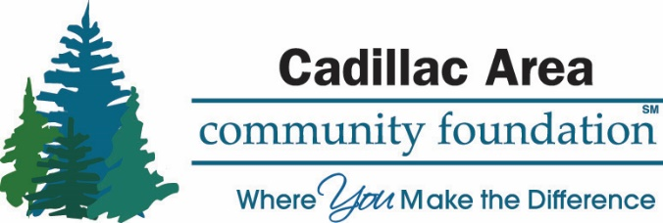

POLICIES & PROCEDURES FOR NON-ENDOWED DONOR ADVISED FUND
Approved July 17, 2019

Listed below are policies to follow and the steps to take in order to make recommendations of distributions from non-endowed donor-advised funds.

- Either send a letter or fill out the Recommendation Form and send it to the Foundation. Retain a copy for your record. We will acknowledge receipt of your suggestion(s).

- Grants will be paid to organizations recognized by the Internal Revenue Service as
Tax-exempt charities. Although our main focus is the Cadillac area, grants may also be made to charitable organizations located elsewhere in Michigan and throughout the United States.

- While by law we cannot fulfill pledges of financial support a donor has already made in his/her own name, the Foundation can make a pledge of future support from the fund for a donor. Such a pledge would be limited to the current assets in the fund.

- U.S. tax law does not permit the use of charitable dollars for benefits rendered to a donor (e.g. museum membership, tickets to benefits, etc.). The fund could make grants to charities in lieu of tickets.

- Non-Endowed Donor-Advised fund recommendations can be made at any time, using the Non-Endowed Donor-Advised Fund Grant Recommendation(s) Form. The Board of Trustees has approval power in this regard and distribution will be made within 30 days of the Cadillac Area Community Foundation Board of Trustees' approval.

- The Foundation requires a minimum founding contribution of Twenty-Five Thousand Dollars ($25,000). The Fund must have a minimum balance of $5,000 if the fund balance falls below Five Thousand, ($5,000) for a period of 24 months the fund balance will be moved to an unrestricted fund of the Community Foundation.
- The minimum amount of any single distribution from a non-endowed donor-advised fund shall be Five Hundred ($500) or greater.

- When a grant is made the Foundation will send an award letter to the organization. The name of the Fund will be identified in the award letter, unless otherwise instructed. A copy of this award letter will be sent to the donor-advisor at the same time.

NON-ENDOWED DONOR-ADVISED RECOMMENDATIONS

TO: The Board of Trustees
Cadillac Area Community Foundation
201 N. Mitchell Street, Suite 101
Cadillac, MI 49601

Name of Fund:

In accord with the terms of the Donor-Advised Fund which we have established in the Community Foundation, we herewith recommend that the Board of Directors approve the distributions of the following charitable grants to the non-profit organizations named, for the purposes stated:

Organization Name:

Organization Address:

Organization Contact Name/s:

Organization Telephone Number:

Please attach a copy of Organization Tax Status (copy if IRS letter of determination with Tax ID #)

Purpose of Grant:

Amount of Grant:

We/I understand that this is a recommendation only and not a directive. We also affirm that the recommended distributions do not represent the payment of any pledge(s) or other financial obligations of the undersigned.

Signature of Donor Advisor Date

Signature of Donor Advisor Date

(Only one Donor Advisors signature is required if serving as an authorized representative)

