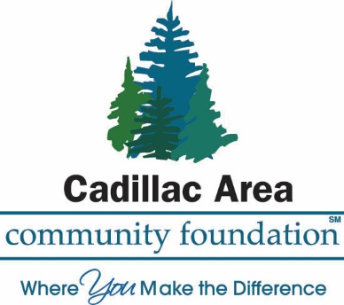
PROFESSIONAL CAREER DEVELOPMENT
SCHOLARSHIP APPLICATION FORM
The Common Scholarship Application Form is used for Student Scholarship Programs facilitated by the Cadillac Area Community Foundation. Please check off each of the scholarship programs for which you would like to be considered from the list below.

WEXFORD-MISSAUKEE ISD SCHOLARSHIP:

______Helen and Harvey Pell Fund for Education Professional Career Development Scholarship that provides awards for post-college training; may also be made to students to attend technical, professional, or cultural institutions such as Interlochen Arts Academy, engineering school, teacher training programs, graduate school, and/or continuing education programs. This Scholarship Award is available to current residents within the Wexford-Missaukee ISD; for current students or adults returning to the classroom.
APPLICANT NAME: ________________________________________DATE OF BIRTH: _____________________________
ADDRESS: _____________________________________________________________________________________________________
TELEPHONE #:__________________________ EMAIL ADDRESS: _______________________________________________
COLLEGE ATTENDING: ____________________________________________________________________________________
APPLICANTS SOCIAL SURCRITY NUMBER: ______________________________

The following attachments are required to be submitted WITH your application.

*CURRENT COLLEGE STUDENT: (or if you have taken any college courses within the last three years) Submit an OFFICIAL TRANSCRIPT showing courses and grades (high school students attending college classes concurrently are excluded from this requirement)—invoice of the current amount due

*A TWO PAGE, TYPED, DOUBLE SPACED, USING A 12-POINT FONT, PERSONAL ESSAY introducing yourself, describe your course of study in college, your school choice, and career choice when you are finished with school. Also include how you may have grown and learned from personal or family challenges, i.e., health, financial, etc., that you consider pivotal to your maturing. Please close your essay describing where you see yourself in 5 years.

Provide awards for post-college training; may also be made to students to attend technical, professional, or cultural institutions such as Interlochen Arts Academy, engineering school, teacher training programs, graduate school, and/or continuing education programs Please write a one-page essay that introduces you, explains why you are applying for this scholarship, if it will lead to new employment or enhance your current employment, and what your financial need is.
Leadership –List positions of Leadership that you have held. (i.e., Class officer, Sports Teams, Clubs, Church, Employment). Limit your response to the last two years.
Service – List examples that demonstrate your actions, including philanthropy through volunteerism and/or generosity, with or on behalf of others, without any direct financial or material compensation. Service contributions to scouts, schools, clubs, committees, classmates, church, and community at large will all be considered. Limit your response to the last two years
Character – List examples of your behavior that demonstrate the qualities of respect, responsibility, trustworthiness, fairness, caring, and citizenship. Please list employment, school activities, at least one extracurricular activity or sports participation that impacted your life, and special recognition you may have received. Limit your response to the last two years.

Please submit your completed scholarship application, with requested attachments, to:

Cadillac Area Community Foundation

201 North Mitchell Street, Suite 101

Cadillac, Michigan 49601

Or

d.lanc@cadillacfoundation.org

Question? 231-775-9911 | Doreen Lanc, Executive Director

