The Cadillac Area Men’s Giving Circle supports projects of the unmet needs of men and boys in the Cadillac Area.

GRANT APPLICATION

Name of Organization: __________________________________________________________________________
Contact: ______________________________________________Contact #: ______________________________
Address: ___________________________________________________________________ Cadillac, MI 49601

Email: __________________________________________________Amount Requested: $ _________________

Please attach a brief proposal describing:
1. Project
2. Unmet need
3. Anticipated number of men and boys’ it will benefit
4. Include IRS documentation for your 501c(3) charitable organization status, educational organization

Application Deadline: March 15th
Applicants will be notified by May 1.

Email: cacf@cadillacfoundation.org or Mail: Cadillac Area Community Foundation
Men’s Giving Circle
201 North Mitchell Street, Ste. 101
Cadillac, MI 49601
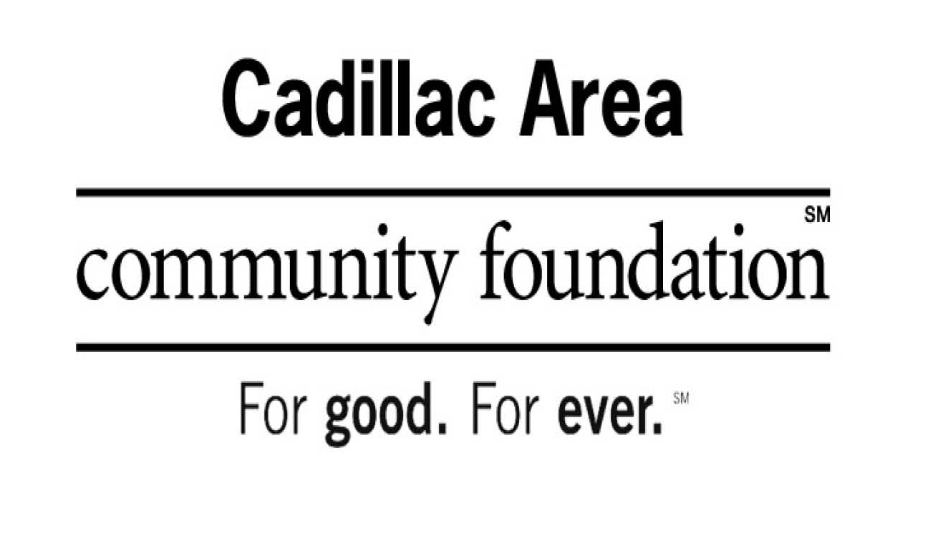

Questions? Call 231-775-9911

