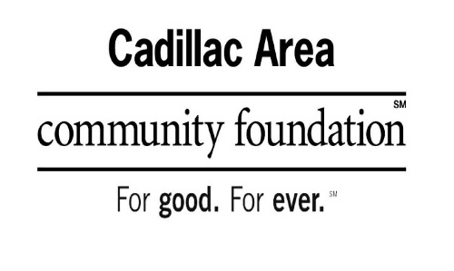

Wexford-Missaukee Fund of Hope
Scholarship Application Form
APPLICANT NAME: _____________________________DATE OF BIRTH: _________
ADDRESS: ____________________________________________________________
CONTACT #:___________________________________________________________
EMAIL ADDRESS: ______________________________________________________
Eligibility:
Fund of Hope Scholarship is available to current residents of the Wexford-Missaukee ISD area graduating from high school and Wexford Missaukee Career Technical Center students within the Wexford Missaukee Intermediate School District.
The Fund provides scholarships to eligible students who are attending their first or second year of a certificate program, a two-year or four-year college/university in the State of Michigan.
Scholarship areas of focus are; financial need, academic ability, and character. The scholarship can be used for books, tuition, and housing. It shall be paid directly to the university, college, and/or institution of higher education.
a. Graduate from the Wexford Missaukee ISD School District
b. Grade point average 2.5 or better
c. Financial need
The following attachments are required to be submitted WITH your application.
- Expected Family Contribution (EFC) and your Student Aid Report (SAR).
- Most recent TRANSCRIPT, ACT, and/or SAT WITH SCORE REPORTS.
- Letter of acceptance from your chosen college/university/skilled trades school
- A brief narrative explains your participation in student organizations, competitions, projects, and/or leadership opportunities, and future career plans.

A complete application must be turned in to the Cadillac Area Community Foundaiton by March 1.
Cadillac Area Community Foundation
201 North Mitchell St. Ste. 101
Cadillac, MI 49601

If you have any questions, please get in touch with the Cadillac Area Community Foundation at 231-775-9911 or email cacf@cadillacfoundation.org

