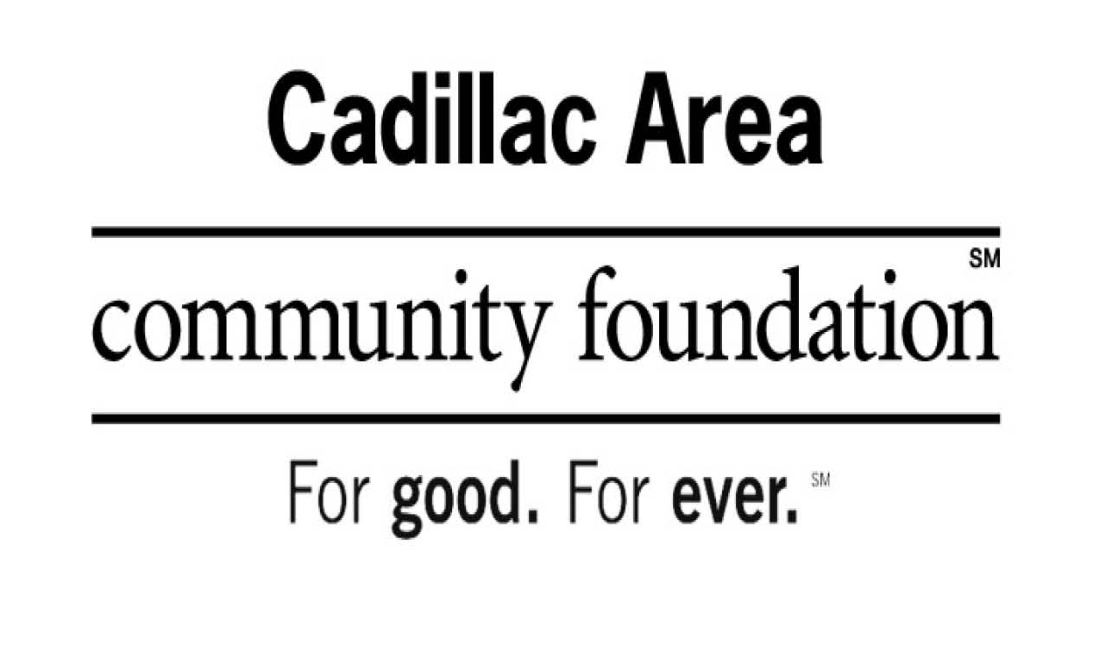
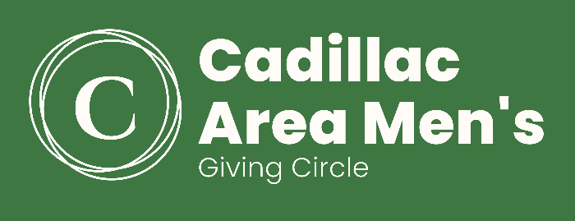
The Cadillac Area Men’s Giving Circle supports projects of the unmet needs of men and boys in the Cadillac Area.
Qualified applicants must be a nonprofit group and/or organization that hold a 501(c) (3) status that wish to offer a program or project to benefit the quality of life for men & boys in the Cadillac Area.

GRANT APPLICATION | Due by March 15

Name of Organization: __________________________________________________________________________
Organization Tax ID #: _________________________________________________________________________
Contact: ______________________________________________Contact #: ______________________________
Address: ___________________________________________________________________ Cadillac, MI 49601

Email: __________________________________________________Amount Requested: $ _________________

Please attach a brief proposal describing:
1. Project/Program
2. Unmet need
3. Anticipated number of men and boys’ it will benefit
4. List of board members
5. Financials
Grants will note be made for:
*Sectarian or political programs *Fund Raising campaigns
*Endowments *Conferences
*Grants to individuals
*Mileage/Benefits

Email: cacf@cadillacfoundation.org or Mail: Cadillac Area Community Foundation
Men’s Giving Circle
201 North Mitchell Street, Ste. 101
Cadillac, MI 49601

Questions? Call 231-775-9911

