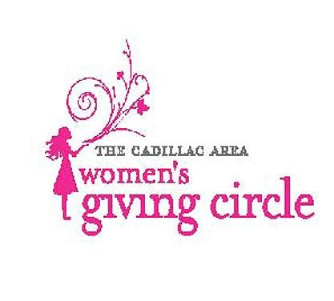
CADILLAC AREA WOMEN’S GIVING CIRCLE
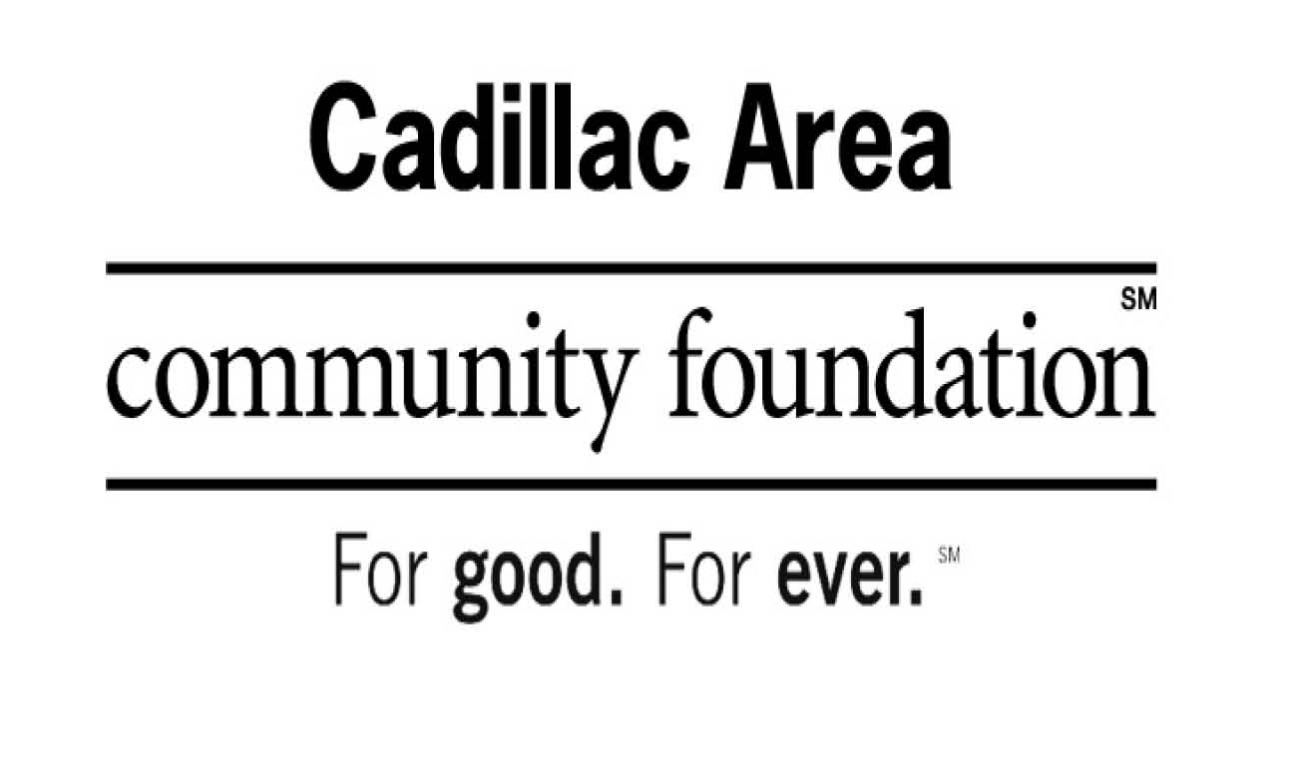

GRANT APPLICATION

The Cadillac Area Women’s Giving Circle supports projects that promote the economic self-sufficiency and well-being of women and girls. The Circle anticipates that it will award one to five grants between $1,000 and $7,500. You are invited to submit this cover sheet with a brief proposal for the Circle to review. After the initial review, you may be invited to meet with Circle members to discuss your project. Proposals due March 1

Name of Organization: ___________________________________________________

Address: ___________________________________________________

___________________________________________________

Phone Number: ___________________________________________________

Name of Project: ___________________________________________________

Amount Requested: _________________ Dates of Project: ________________

Contact Person: ___________________________________________________

Signature of Authorized Official: ___________________________________________

Please attach a brief proposal (two-page maximum) describing:
- Purpose: the innovative purpose of the program or project
- Need: the need that the program or project will help meet
- Objectives: the objectives of the project
- Benefits/Outcomes: what are the anticipated benefits/outcomes
- Evaluations: how you will measure the results of the projects
- Funding: a budget for the project (including any other funding) and plans for future sustainability

Please mail this cover sheet with the following:
- Your proposal
- IRS documentation for your 501c(3) charitable organization status, educational organization status, and/or governmental organization status.
- Organization mission and purpose
- Organization board of directors
5. Most recent financial statements.
Email: cacf@cadillacfoundation.org or Mail: Cadillac Area Community Foundation
Women’s Giving Circle
201 North Mitchell Street, Ste. 101
Cadillac, MI 49601

Questions? Call 231-775-9911

