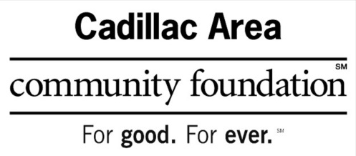

201 N. Mitchell St., Suite 101

Cadillac, Mi 49601

231-775-9911

[www.cadillacfoundation.org](http://www.cadillacfoundation.org)

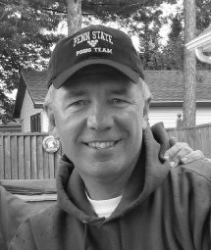

**DAVID A. COOK MEMORIAL**

**SCHOLARSHIP FUND**

**FOR CIVIL AND**

**ENVIRONMENTAL ENGINEERING**

**AT MICHIGAN STATE UNIVERSITY**

This fund was established in 2013 by Dave’s wife, Dorcas “Dori” Cook, to honor the man she dearly loved. Dave lived his life to the fullest and made a point to tell and show his love to those he cherished. He took pride in being great at his job and in providing for his family. As hard as he worked, he also knew how to have fun. He was silly and had a quick wit. He had a great three-point jump shot and loved golf and tennis. He was loving, kind, generous, and forgiving. He was an adoring father and raised his daughters to know they could accomplish anything they put their minds to. He had many passions in life that took him all over the world. He took and developed amazing photographs, provided his family with fish and mushrooms, and loved to cheer on his Michigan State Spartans. He set an amazing example of what it means to be a good husband, a good father, and a good man.

Dave graduated from Michigan State University in 1975 with a degree in Mechanical Engineering. He was a devoted Spartan and was extremely proud of his alma mater. Over the course of his life he became passionate about the environment and pushed for green energy and construction.  It is in the light of his love for the environment that we have created the David A Cook Memorial Scholarship Fund for Civil and Environmental Engineering at Michigan State University. It is our way of creating a legacy for Dave and sharing his vision for the future.

Please see the attached application for the criteria to apply for the David A. Cook Memorial Scholarship Fund for Civil and Environmental Engineering.

**DAVID A. COOK MEMORIAL SCHOLARSHIP FUND FOR CIVIL AND ENVIRONMENTAL ENGINEERING AT MICHIGAN STATE UNIVERSITY.**

**Eligibility requirements:**

1. Any **currently enrolled**, second year or higher**,** and graduate students in civil & environmental engineering at Michigan State University.
2. Must have a **GPA of at least 3.0.**
3. Applicant must be a member of an **ABET-accredited** Civil and/or Environmental Engineering Program and be in good standing at the time of application and award.
4. A scholarship may be awarded only to a student who will employ it to **continue his/her formal education** at Michigan State University. The scholarship will be paid directly to Michigan State University.

**Applications must include:**

1. Completed application form.
2. Sealed letter of recommendation from your Faculty Advisor.
3. One sealed official transcript for each school attended **after high school**.
4. Brief résumé. Include honors, activities, organizations, ASCE activities (including any offices held), and any work experience.
5. Completed FAFSA with the EFC.
6. Half page essay regarding your choice of study.

**Procedure:**

One **complete** application package containing one original of all items listed above must be received by the Cadillac Area Community Foundation no later than **September 15**. All items must be collected by the applicant and sent as one complete application package.Application packages missing any of the above items will not be considered.

**Selection Criteria:**

Selection Criteria is based on GPA and Financial Need with attention given to work history and volunteer efforts.

**Scholarship Conditions:**

The ***$5,000*** Scholarship is to be used for tuition, books, housing, and lab fees. The Scholarship will be paid directly to Michigan State University on behalf of the selected applicant (non-taxable). The award will be paid in a lump sum in August. The Board of Trustees of the Cadillac Area Community Foundation reserves the right to suspend the grant in any given year based on limited available Fund dollars and/or a lack of acceptable applicants.

**Submit Completed Application With Attachments outlined on Page 1 to:**

**Cadillac Area Community Foundation**

**201 North Mitchell Street**

**Suite 101**

**Cadillac, Michigan 49601**

Deadline September 15

|  |  |  |
| --- | --- | --- |
|  | | |
| **DAVID A. COOK MEMORIAL SCHOLARSHIP FUND**  **FOR CIVIL AND ENVIRONMENTAL ENGINEERING AT**  **MICHIGAN STATE UNIVERSITY APPLICATION** | | |
| Name: (Last) (First) (Middle) | | Social Security Number |
| Home Address:  Street Address)  (City) (State) (Zip Code) | | |
| School Address: (The address you use while you are at school).  (Street Address)  (City) (State) (Zip Code) | | |
| Telephone:  (home) (cell) | | E-mail: |
| Major: | | Minor: |
| GPA (min. 3.0 - 4.0) : | Expected Date of Graduation (mo / yr) : | |
| **I hereby state that all information contained within this application is true and correct to the best of my knowledge**.  ________________________________________________________________________________________  Applicant Signature Date  _____________________________________________________________________________________________________________  ASCE Faculty Advisor Signature Date  _____________________________________________________________________________________________________________  ASCE Faculty Advisor Name (please print) | | |

If you have any questions, please email Ashley at [cacf@cadillacfoundation.org](mailto:cacf@cadillacfoundation.org)   
or call 231-775-9911

Submit Completed Application With Attachments to:

Cadillac Area Community Foundation

201 North Mitchell Street, Suite 101

Cadillac, Michigan 49601

Deadline September 15.